**Food Classification**

**Dataset: Food-11 Image Dataset**

Food types Recognition is one of the most useful application of Object Recognition, and can be sued in various aspects of our lives and also help in business which focus on edible items.

This dataset contains 16643 food images grouped in 11 major food categories. It is split into three parts – Evaluation, Training and Validation

Each split contains 11 categories of food:

* Bread
* Dairy product
* Dessert
* Egg
* Fried food
* Meat
* Noodles-Pasta
* Rice
* Seafood
* Soup
* Vegetable-Fruits

These categories of Food constitute the classes of our model

Food-11 Image Classes

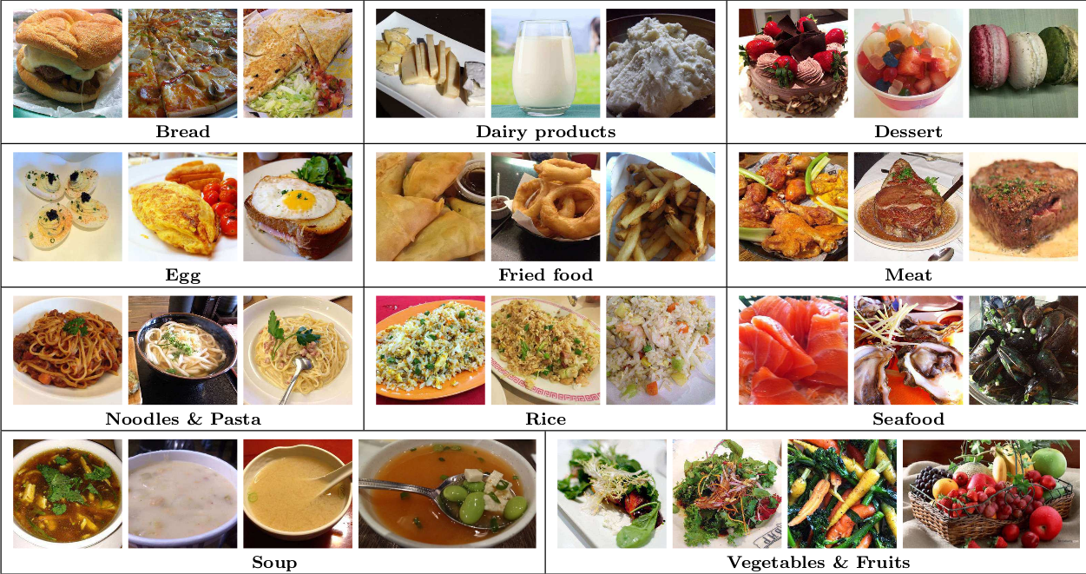

Model Summary

The Food Classification Model uses ResNet for classifying various food types such as bread, dairy products, soup, rice, etc.

This model has 2 layers of 256 and 128 neurons respectively.

The model also includes 2 dropouts of Dropout values 0.5 and 0.3 for classification and approximately 25 Million parameters.

It gives 44% and 39% accuracy for 15 epochs.

Model Evaluation

|  |  |
| --- | --- |
| Accuracy |  |
| Loss |  |